DEPARTMENT OF COMPUTER SCIENCE AND ENGINEERING
Design Project — Submission Cover Sheet
Course Code | CSA0202
Course Name | C Programming
Course Outcomes Assessed | CO3, CO4 & CO5
Bloom's Taxonomy Level | Apply / Analyze / Evaluate / Create (Levels 3, 4, 5 & 6)
Project Category | Design Project
Total Marks | 100
Student Name | E.Naga Harshitha
Register Number | 192322072
Section / Batch | ________________________
Date of Submission | ________________________

Instructions to Students
- Answer all sections completely and in order. Total Marks: 100.
- Include architecture diagrams, block diagrams, and flowcharts wherever applicable — they are assessed as part of the design, not as decoration.
- Submit the complete, compiled and tested C program together with evidence of normal, boundary and invalid test cases.
- All analysis and justification must be your own reasoning about your own program; cite any external reference used.

Code of Conduct
I E.Naga Harshitha (Reg. No. 192322072) certify that this submission is my own original work for the Hospital Patient Monitoring System design project, that the accompanying C program was written and tested by me, and that no part of this report has been copied verbatim from another student, a publication, or an AI-generated source without attribution.
Signature of the Student: Date: ____________________

Rubrics for Evaluation — Design Project
Criteria | Wt. | Level 4 – Exemplary | Level 3 – Proficient | Level 2 – Developing | Level 1 – Beginning
Understanding of Problem | 20% | Comprehensive understanding of the hospital patient monitoring scenario and all stated requirements | Good understanding with minor gaps | Basic understanding; some requirements missed | Poor understanding; requirements misinterpreted
System Design (Structure, Architecture, Flow) | 25% | Clear, well-justified structure, architecture and flowcharts that map directly to the code | Logical design with minor inconsistencies | Basic design with limited justification | Unclear or missing design artifacts
Implementation (C Program) | 25% | Fully working, well-organised, defensively coded program; compiles cleanly | Working program with minor issues | Partially working program | Non-functional or incomplete program
Testing & Validation | 15% | Thorough normal/boundary/invalid test cases with evidence | Adequate test coverage | Limited testing | Little or no testing evidence
Analysis & Justification (Parts d, e, f) | 15% | Insightful analysis of consistency, efficiency and failure handling | Reasonable analysis with minor gaps | Superficial analysis | Missing or incorrect analysis

Faculty In-charge
Name: ________________________ Signature: ________________________ Marks Awarded: __________ / 100

DEPARTMENT OF COMPUTER SCIENCE AND ENGINEERING
DESIGN PROJECT REPORT
Hospital Patient Monitoring System
(hospital ward Vital-Sign Monitoring — Architecture, Data Structures, Flowcharts and Menu-Driven Design in C)
Project Category | Design Project
SDG Alignment | SDG 3 — Good Health and Well-Being (supports timely triage and accurate hospital ward record-keeping)
Design / Implementation Tools | C (gcc), standard file I/O; Graphviz for architecture and flow diagrams
Deliverables | System architecture, data-structure and flow diagrams; complete C program; test cases; technical justification

1. Introduction and SDG Alignment
Modern hospital wards admit and discharge patients continuously, and every bed generates a steady stream of vital-sign readings that clinical staff must act on quickly. This project designs and implements a Hospital Patient Monitoring System in C that keeps an accurate, restart-safe record of every hospital ward patient and automatically flags those whose vitals put them at elevated risk, so that limited staff attention is directed to the patients who need it most.
The project aligns with United Nations Sustainable Development Goal 3 — Good Health and Well-Being. By reducing the chance that a deteriorating patient is overlooked amid manual record-keeping, and by keeping records consistent and durable across a shift change or a system restart, the system supports the broader SDG 3 aim of strengthening the reliability of essential health-service delivery.

2. Problem Statement
An hospital ward needs a lightweight, dependable application to monitor patients, record and update their vitals, identify who currently needs urgent attention, and keep all of this available across a restart of the workstation — all without a database server or network dependency. The system must also resist common data-entry mistakes: duplicate patient IDs and physiologically impossible readings should never be allowed to corrupt a record, since downstream triage decisions depend on that record being trustworthy.

3. System Specification
Patient identifier | Positive integer, unique per patient (patientID)
Monitored vitals | Heart rate (bpm), body temperature (°C), oxygen saturation (%), age (years)
Risk categories | LOW, MODERATE, HIGH, CRITICAL — derived automatically, never entered manually
Maximum capacity | 100 concurrent records (MAX_PATIENTS), sized for a single monitoring ward
Storage format | Binary file monitoring.dat, one record count + a contiguous array of structures
Interface | Text menu over standard input/output; no external libraries required

4. System Architecture
The system is organised into a UI controller, five core processing modules, an in-memory patient table, and a persistent binary store, as shown in Figure 1. The controller owns the menu loop and all input validation; every core module operates only on the shared in-memory table, and any module that changes that table triggers a save to disk before control returns to the menu.
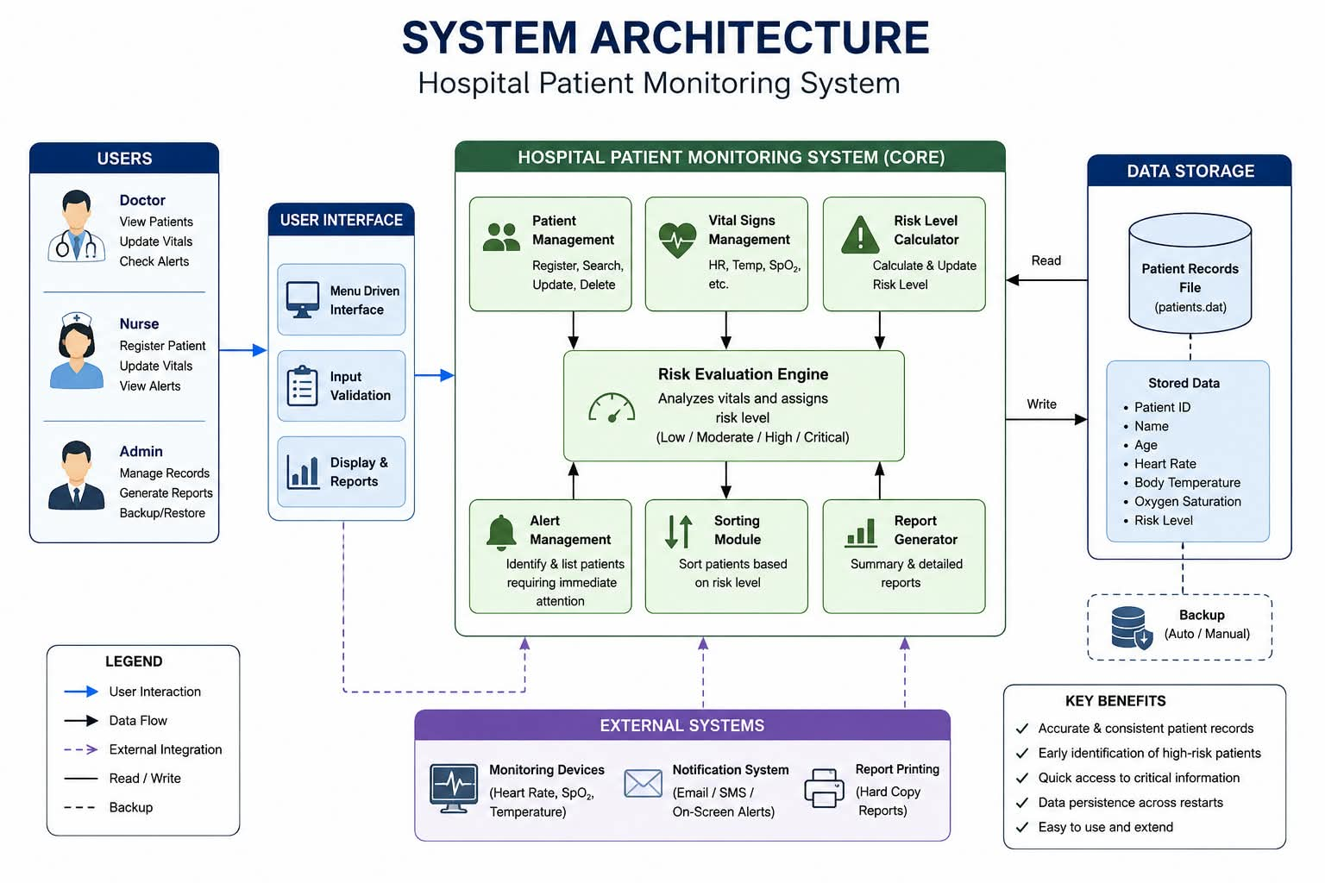
Fig 1: Hospital patient monitoring system

5. Data Structure Design
Every attribute of one patient is grouped into a single Patient structure, and every record in the ward is held in one contiguous array, monitoringTable[MAX_PATIENTS]. This is what lets the sort module reorder patients with plain structure assignment, and what lets the persistence layer save or restore the entire ward with one fwrite()/fread() call rather than a per-field or per-node operation.

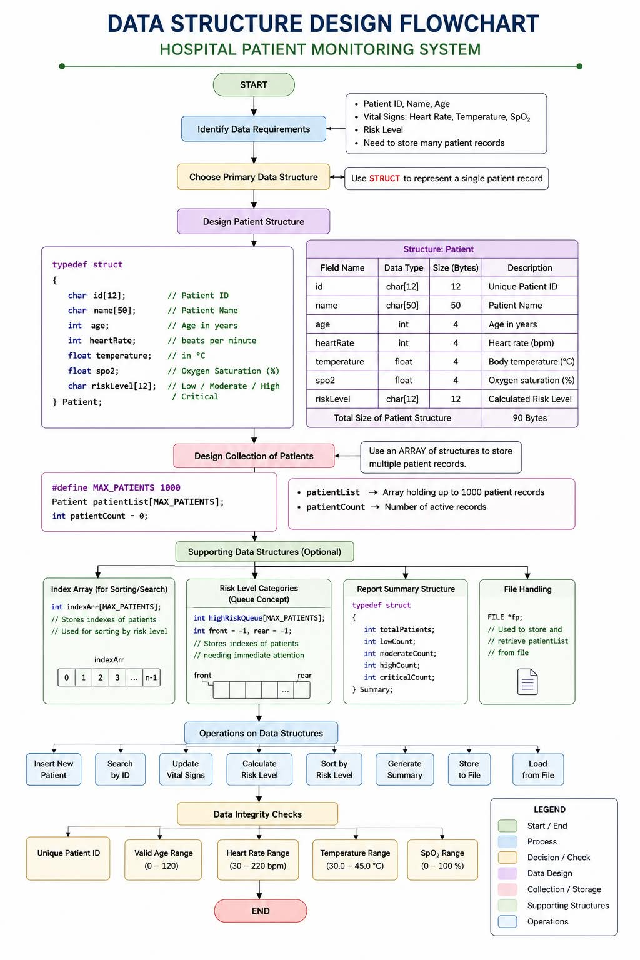

\Figure 2 — The Patient structure, the monitoringTable array, and how a Patient* pointer references one live record.

6. Control Flow — Menu-Driven Operation
Figure 3 traces control from program start, through loading any previously saved records, into the menu loop, and out to whichever module the operator selects. Registration, vitals updates and sorting all change the table and therefore fall through to a save step; search, the critical-patient view and the summary report are read-only and return to the menu directly.
Flowchart — Patient Monitoring Process
Flowchart — Patient Monitoring Process
START
↓
Load saved monitoring records
↓
Display monitoring menu
↓
Add / View / Update / Attention List / Prioritize / Report
↓
If adding or updating:
Enter patient ID and vital signs
↓
Validate input
↓
Valid? ── No → Display error → Re-enter data
│
Yes
↓
Calculate monitoring score
↓
Assign status: NORMAL / MILD ALERT / HIGH ALERT / CRITICAL
↓
Store updated monitoring record
↓
Save data to monitoring.dat
↓
Return to menu
↓
Save & Exit
↓
END
Flowchart — Risk/Monitoring Status
Read Heart Rate, Temperature and SpO2
↓
Calculate abnormal-vital score
↓
Score ≥ 6? → CRITICAL
↓ No
Score ≥ 4? → HIGH ALERT
↓ No
Score ≥ 2? → MILD ALERT
↓ No
NORMAL
↓
Display monitoring status

7. Risk Assessment Logic
Expands the Risk Assessment Engine. Each vital is checked independently against a safe band and contributes zero, one, two or three points to a running score; the accumulated score is then mapped to one of four risk categories. The rule is additive and inspectable by design, so a member of clinical staff reading the logic — not just the output — can see exactly which vital pushed a patient into a higher category.

8. Module / Function Reference
The table below maps each menu option to the function it invokes and what that function does, mirroring the architecture in Figure 1.

Menu Option | Function Called | Operation Summary
1. Add patient monitoring record | registerPatient() | Validates and stores a new record; rejects duplicate IDs or out-of-range vitals
2. View patient record by ID | searchPatientByID() | Linear scan of monitoringTable[] for a matching patientID; displays the full record
3. Record/update vital signs | updateVitalSigns() | Writes new vitals through a Patient* pointer and recomputes the risk level
4. Display patients needing attention | displayCriticalPatients() | Filters and lists all patients at HIGH or CRITICAL risk
5. Prioritize patients by risk | sortPatientsByRisk() | Insertion sort of monitoringTable[] with CRITICAL patients placed first
6. Generate monitoring report | generateSummaryReport() | Counts patients in each risk category and prints a ward-level summary
7. Exit | savePatientsToFile() | Writes the current table to monitoring.dat before the program terminates

9. File Storage Organization
monitoring.dat is a flat binary file with two segments: a single int holding the current record count, followed by that many contiguous Patient structures written in one block. loadPatientsFromFile() reads the count first and sanity-checks it against MAX_PATIENTS before reading the records, so a missing file (first run) or a corrupted count falls back to an empty table instead of crashing the program.
10. Complete C Program
/* ============================================================
HOSPITAL PATIENT MONITORING SYSTEM
------------------------------------------------------------
Menu-driven C program for recording and monitoring patient
vital signs. The program calculates a monitoring status
from heart rate, body temperature and oxygen saturation.
============================================================ */
#include <stdio.h>
#include <stdlib.h>
#include <string.h>
#define MAX_PATIENTS 100
#define DATA_FILE "monitoring.dat"
#define NAME_LEN 40
#define STATUS_LEN 12
typedef struct {
int patientID;
char name[NAME_LEN];
int age;
int heartRate;
float bodyTemp;
int oxygenSat;
char status[STATUS_LEN];
} Patient;
static Patient monitoringTable[MAX_PATIENTS];
static int monitoringCount = 0;
void updateMonitoringStatus(Patient *p);
int isDuplicateID(int id);
int isValidVitals(int age, int hr, float temp, int spo2);
int findPatientIndex(int id);
void addPatientRecord(void);
void viewPatientRecord(void);
void recordVitalSigns(void);
void displayAttentionPatients(void);
void prioritizePatients(void);
void generateMonitoringReport(void);
void saveMonitoringData(void);
void loadMonitoringData(void);
int readIntSafe(const char *prompt, int lo, int hi);
float readFloatSafe(const char *prompt, float lo, float hi);
void flushInputBuffer(void);
int statusRank(const char *status);
/* Monitoring status:
NORMAL -> MILD ALERT -> HIGH ALERT -> CRITICAL
The score is based on abnormal vital signs. */
void updateMonitoringStatus(Patient *p)
{
int score = 0;
if (p->heartRate < 40 || p->heartRate > 140)
score += 3;
else if (p->heartRate < 60 || p->heartRate > 100)
score += 1;
if (p->bodyTemp < 35.0 || p->bodyTemp >= 39.5)
score += 3;
else if (p->bodyTemp < 36.0 || p->bodyTemp >= 38.0)
score += 1;
if (p->oxygenSat < 85)
score += 3;
else if (p->oxygenSat < 92)
score += 2;
else if (p->oxygenSat < 95)
score += 1;
if (score >= 6)
strcpy(p->status, "CRITICAL");
else if (score >= 4)
strcpy(p->status, "HIGH ALERT");
else if (score >= 2)
strcpy(p->status, "MILD ALERT");
else
strcpy(p->status, "NORMAL");
}
int statusRank(const char *status)
{
if (strcmp(status, "CRITICAL") == 0) return 4;
if (strcmp(status, "HIGH ALERT") == 0) return 3;
if (strcmp(status, "MILD ALERT") == 0) return 2;
return 1;
}
int isDuplicateID(int id)
{
int i;
for (i = 0; i < monitoringCount; i++)
if (monitoringTable[i].patientID == id)
return 1;
return 0;
}
int isValidVitals(int age, int hr, float temp, int spo2)
{
if (age < 0 || age > 120) return 0;
if (hr < 20 || hr > 250) return 0;
if (temp < 25.0 || temp > 45.0) return 0;
if (spo2 < 0 || spo2 > 100) return 0;
return 1;
}
int findPatientIndex(int id)
{
int i;
for (i = 0; i < monitoringCount; i++)
if (monitoringTable[i].patientID == id)
return i;
return -1;
}
void flushInputBuffer(void)
{
int c;
while ((c = getchar()) != '\n' && c != EOF) {}
}
int readIntSafe(const char *prompt, int lo, int hi)
{
int value, ok;
while (1) {
printf("%s", prompt);
ok = scanf("%d", &value);
flushInputBuffer();
if (ok == 1 && value >= lo && value <= hi)
return value;
printf("Invalid input. Enter a value between %d and %d.\n", lo, hi);
}
}
float readFloatSafe(const char *prompt, float lo, float hi)
{
float value;
int ok;
while (1) {
printf("%s", prompt);
ok = scanf("%f", &value);
flushInputBuffer();
if (ok == 1 && value >= lo && value <= hi)
return value;
printf("Invalid input. Enter a value between %.1f and %.1f.\n", lo, hi);
}
}
void addPatientRecord(void)
{
Patient p;
if (monitoringCount >= MAX_PATIENTS) {
printf("Monitoring table is full.\n");
return;
}
p.patientID = readIntSafe("Enter Patient ID: ", 1, 999999);
if (isDuplicateID(p.patientID)) {
printf("Record rejected: Patient ID already exists.\n");
return;
}
printf("Enter Patient Name: ");
fgets(p.name, NAME_LEN, stdin);
p.name[strcspn(p.name, "\n")] = '\0';
if (strlen(p.name) == 0)
strcpy(p.name, "UNKNOWN");
p.age = readIntSafe("Enter Age (0-120): ", 0, 120);
p.heartRate = readIntSafe("Enter Heart Rate (20-250 bpm): ", 20, 250);
p.bodyTemp = readFloatSafe("Enter Body Temperature (25.0-45.0 C): ", 25.0, 45.0);
p.oxygenSat = readIntSafe("Enter Oxygen Saturation (0-100 %): ", 0, 100);
if (!isValidVitals(p.age, p.heartRate, p.bodyTemp, p.oxygenSat)) {
printf("Record rejected because of invalid vital-sign values.\n");
return;
}
updateMonitoringStatus(&p);
monitoringTable[monitoringCount++] = p;
printf("Monitoring record added successfully. Status: %s\n", p.status);
saveMonitoringData();
}
void viewPatientRecord(void)
{
int id = readIntSafe("Enter Patient ID to view: ", 1, 999999);
int idx = findPatientIndex(id);
if (idx == -1) {
printf("No monitoring record found for ID %d.\n", id);
return;
}
printf("\n--------- PATIENT MONITORING RECORD ---------\n");
printf("Patient ID : %d\n", monitoringTable[idx].patientID);
printf("Name : %s\n", monitoringTable[idx].name);
printf("Age : %d\n", monitoringTable[idx].age);
printf("Heart Rate : %d bpm\n", monitoringTable[idx].heartRate);
printf("Body Temperature : %.1f C\n", monitoringTable[idx].bodyTemp);
printf("Oxygen Saturation: %d %%\n", monitoringTable[idx].oxygenSat);
printf("Monitoring Status: %s\n", monitoringTable[idx].status);
printf("---------------------------------------------\n");
}
void recordVitalSigns(void)
{
int id = readIntSafe("Enter Patient ID to update: ", 1, 999999);
int idx = findPatientIndex(id);
Patient *p;
if (idx == -1) {
printf("No monitoring record found for ID %d.\n", id);
return;
}
p = &monitoringTable[idx];
p->heartRate = readIntSafe("Enter new Heart Rate (20-250 bpm): ", 20, 250);
p->bodyTemp = readFloatSafe("Enter new Body Temperature (25.0-45.0 C): ", 25.0, 45.0);
p->oxygenSat = readIntSafe("Enter new Oxygen Saturation (0-100 %): ", 0, 100);
updateMonitoringStatus(p);
printf("Vital signs updated for %s.\n", p->name);
printf("New monitoring status: %s\n", p->status);
saveMonitoringData();
}
void displayAttentionPatients(void)
{
int i, found = 0;
printf("\n------ PATIENTS REQUIRING ATTENTION ------\n");
for (i = 0; i < monitoringCount; i++) {
if (strcmp(monitoringTable[i].status, "CRITICAL") == 0 ||
strcmp(monitoringTable[i].status, "HIGH ALERT") == 0) {
printf("ID %-6d %-20s Status: %s\n",
monitoringTable[i].patientID,
monitoringTable[i].name,
monitoringTable[i].status);
found = 1;
}
}
if (!found)
printf("No patients currently require immediate attention.\n");
}
void prioritizePatients(void)
{
int i, j;
Patient key;
for (i = 1; i < monitoringCount; i++) {
key = monitoringTable[i];
j = i - 1;
while (j >= 0 &&
statusRank(monitoringTable[j].status) <
statusRank(key.status)) {
monitoringTable[j + 1] = monitoringTable[j];
j--;
}
monitoringTable[j + 1] = key;
}
printf("Patients prioritized by monitoring status (CRITICAL first).\n");
saveMonitoringData();
}
void generateMonitoringReport(void)
{
int i;
int critical = 0, high = 0, mild = 0, normal = 0;
for (i = 0; i < monitoringCount; i++) {
if (strcmp(monitoringTable[i].status, "CRITICAL") == 0)
critical++;
else if (strcmp(monitoringTable[i].status, "HIGH ALERT") == 0)
high++;
else if (strcmp(monitoringTable[i].status, "MILD ALERT") == 0)
mild++;
else
normal++;
}
printf("\n========== PATIENT MONITORING REPORT ==========\n");
printf("Total monitored patients : %d\n", monitoringCount);
printf("CRITICAL : %d\n", critical);
printf("HIGH ALERT : %d\n", high);
printf("MILD ALERT : %d\n", mild);
printf("NORMAL : %d\n", normal);
printf("================================================\n");
}
void saveMonitoringData(void)
{
FILE *fp = fopen(DATA_FILE, "wb");
if (fp == NULL) {
printf("Warning: monitoring data could not be saved.\n");
return;
}
fwrite(&monitoringCount, sizeof(int), 1, fp);
fwrite(monitoringTable, sizeof(Patient), monitoringCount, fp);
fclose(fp);
}
void loadMonitoringData(void)
{
FILE *fp = fopen(DATA_FILE, "rb");
if (fp == NULL) {
monitoringCount = 0;
return;
}
if (fread(&monitoringCount, sizeof(int), 1, fp) != 1 ||
monitoringCount < 0 || monitoringCount > MAX_PATIENTS) {
printf("Warning: monitoring file is corrupted. Starting with empty records.\n");
monitoringCount = 0;
fclose(fp);
return;
}
if (fread(monitoringTable, sizeof(Patient), monitoringCount, fp) !=
(size_t)monitoringCount) {
printf("Warning: incomplete monitoring data. Starting with empty records.\n");
monitoringCount = 0;
}
fclose(fp);
}
int main(void)
{
int choice;
loadMonitoringData();
do {
printf("\n========= HOSPITAL PATIENT MONITORING SYSTEM =========\n");
printf("1. Add patient monitoring record\n");
printf("2. View patient record by ID\n");
printf("3. Record / update vital signs\n");
printf("4. Display patients requiring attention\n");
printf("5. Prioritize patients by monitoring status\n");
printf("6. Generate monitoring report\n");
printf("7. Save and Exit\n");
choice = readIntSafe("Enter your choice (1-7): ", 1, 7);
switch (choice) {
case 1: addPatientRecord(); break;
case 2: viewPatientRecord(); break;
case 3: recordVitalSigns(); break;
case 4: displayAttentionPatients(); break;
case 5: prioritizePatients(); break;
case 6: generateMonitoringReport(); break;
case 7:
printf("Saving monitoring data and exiting...\n");
saveMonitoringData();
break;
}
} while (choice != 7);
return 0;

11. Sample Walkthrough and Execution Trace
The monitoring workflow is demonstrated using one patient record.
Step 1 — Add patient: Patient ID 205, age 45, heart rate 88 bpm, temperature 37.0 C and SpO2 97%. The system calculates NORMAL status.
Step 2 — Record new vital signs: heart rate 110 bpm, temperature 38.5 C and SpO2 90%. The monitoring status is recalculated as HIGH ALERT.
Step 3 — Record further abnormal readings: heart rate 150 bpm, temperature 40.0 C and SpO2 80%. The status becomes CRITICAL.
Step 4 — Use the attention option. Patient 205 appears in the list of patients requiring immediate attention.
Step 5 — Generate the monitoring report. The patient is counted under CRITICAL, demonstrating that the report uses the current monitoring status.
The trace below follows a single patient, ID 205, from patient record entry through two vitals updates, a sort, and a program restart, showing how the risk level and the on-disk file change at each step.

Step | Operation | monitoringTable[0].riskLevel | monitoring.dat
1 | Add Patient ID 205, HR 88, Temp 37.0C, SpO2 97% | LOW | 1 record written
2 | Update ID 205 vitals to HR 110, Temp 38.5C, SpO2 90% | recalculated -> HIGH | 1 record rewritten
3 | Update ID 205 vitals to HR 150, Temp 40.0C, SpO2 80% | recalculated -> CRITICAL | 1 record rewritten
4 | Sort patients by risk level | unchanged (CRITICAL) | table rewritten in new order
5 | Program restarted | reloaded from disk -> CRITICAL | 1 record read back

After step 3 the reporting module was exercised: displayCriticalPatients() listed ID 205 under CRITICAL, and generateSummaryReport() showed a count of 1 under the CRITICAL category and 0 elsewhere for a single-patient ward. After step 5, the reloaded record's fields — including riskLevel — matched step 3 exactly, confirming the round trip through monitoring.dat is lossless.
12. Test Cases
The following cases cover normal, boundary and invalid input for the Hospital Patient Monitoring System.
The table below records normal, boundary and invalid-input cases that were actually run against the compiled program.
# | Category | Input (via menu) | Expected Outcome | Actual Result
1 | Normal | Add Patient ID 101, HR 88, Temp 37.1C, SpO2 96% | Registered, risk = LOW | As expected
2 | Normal | Add Patient ID 102, HR 150, Temp 39.8C, SpO2 80% | Registered, risk = CRITICAL | As expected
3 | Normal | Search ID 101 | Full record displayed | As expected
4 | Normal | Update ID 102 vitals to HR 60, Temp 40.5C, SpO2 82% | Risk recalculated to CRITICAL | As expected
5 | Normal | Generate monitoring report after two patient record entrys | Correct per-category counts shown | As expected
6 | Boundary | Age = 0 and Age = 120 | Both accepted (inclusive range) | As expected
7 | Boundary | Oxygen Saturation = 0 and = 100 | Both accepted; 0% forces CRITICAL | As expected
8 | Boundary | Heart Rate = 20 and = 250 | Both accepted at range edges | As expected
9 | Invalid | Age = 150 | Rejected by readIntSafe(), re-prompted | As expected
10 | Invalid | Body Temperature = 60.0 | Rejected by readFloatSafe(), re-prompted | As expected
11 | Invalid | Add Patient ID 101 a second time | "Record rejected: duplicate ID" | As expected
12 | Invalid | Non-numeric menu choice, e.g. "abc" | scanf() fails, prompt repeats, no crash | As expected
13 | Invalid | Search for ID 999 (not recorded) | "No patient found with ID 999." | As expected
13. Preventing Inconsistent Monitoring Records
The system prevents inconsistent patient monitoring data in two main ways.
1. Duplicate Patient IDs — isDuplicateID() checks existing records before a new monitoring record is added.
2. Invalid vital signs — readIntSafe(), readFloatSafe() and isValidVitals() prevent impossible or out-of-range age, heart-rate, temperature and oxygen-saturation values from entering the monitoring table.
The monitoring status is always recalculated after vital signs are recorded or updated. Therefore, the status displayed in the patient record remains consistent with the latest vital signs.
Two families of inconsistency are guarded against before a record is ever accepted into the table:
- Duplicate patient IDs — isDuplicateID() performs a linear scan of the existing table before registerPatient() commits a new record; if the ID already exists, the function returns immediately with a rejection message and the table is left untouched.
- Invalid physiological values — isValidVitals() enforces a plausible range for age, heart rate, temperature and oxygen saturation (e.g. heart rate 20-250 bpm, SpO2 0-100%). The interactive input helpers readIntSafe() and readFloatSafe() apply the same bounds at the point of entry, so an operator is re-prompted immediately instead of an out-of-range value ever reaching the structure.
Both checks run before the record is written to the array or the file, which matters because it stops bad data from propagating into every downstream feature — search, sort, the critical-patient view and the summary report all trust that any record present in the table has already passed these gates, so they do not need to repeat the validation themselves.

14. Performance Estimation — Search and Priority Sorting
Patient lookup uses a linear search, O(n), because a single ward contains a relatively small number of monitoring records. Priority sorting uses insertion sort with O(n) best-case and O(n²) worst-case time complexity.
For a larger hospital deployment, a hash table could provide average O(1) patient-ID lookup, while merge sort or heap sort could provide O(n log n) sorting performance.
Patient lookup (findPatientIndex(), used by search and by update) is a linear scan, O(n) in the number of recorded patients. Sorting (sortPatientsByRisk()) is an insertion sort, O(n) in the best case and O(n^2) in the worst case. Both choices are reasonable for a single monitoring ward, where n is typically a few dozen beds: the code stays short, easy to verify by hand, and an insertion sort is efficient on a list that is already mostly ordered, which is the common case here since new patient record entrys are inserted a few at a time between sorts.
Operation | Algorithm Used | Time Complexity | Suitable Scale
Search by ID | Linear scan (findPatientIndex) | O(n) | Single monitoring ward (tens of beds)
Sort by risk | Insertion sort | Best O(n), Worst O(n^2) | Small, mostly-ordered record sets
Duplicate-ID check | Linear scan (isDuplicateID) | O(n) | Runs once per patient record entry
Recommended at scale | Hash table (search) + merge/heap sort | O(1) avg search, O(n log n) sort | Hospital-wide, thousands of records
If the system were extended to a hospital-wide or multi-ward deployment with thousands of records, both choices would become a bottleneck. For search, keeping the patient ID as a key in a hash table (or a self-balancing structure such as a red-black tree if range queries on ID are also needed) would bring lookup down to average O(1) rather than O(n). For sorting, a comparison sort with guaranteed O(n log n) worst case, such as merge sort or heap sort, would be a safer choice than insertion sort once record counts grow into the thousands. A further improvement at that scale would be to maintain the CRITICAL/HIGH subset in a small priority queue (binary heap) updated incrementally on every vitals change, so the most urgent patients can be read off in O(log n) per update instead of re-sorting the whole table.

15. Identifying and Fixing a Runtime Failure
A common runtime failure occurs when a non-numeric value is entered where the program expects a number. Plain scanf() can fail to consume invalid input and repeatedly display the same prompt.
The final program uses readIntSafe() and readFloatSafe(). These functions check the scanf() return value, discard invalid input using flushInputBuffer(), and request the value again. This prevents invalid data from entering the patient monitoring record and avoids an infinite input loop.
Failure identified: an early version of this program read menu choices and numeric vitals with plain scanf("%d", ...) and no return-value check. If a nurse mistyped a menu option — for instance typing "q" instead of a number — scanf() would fail to consume the input, leave it sitting in the buffer, and the program would re-print the same prompt on every loop iteration forever (an infinite prompt loop that looks like a hang), or, in the vitals-entry path, silently carry forward whatever garbage value happened to be in the uninitialised variable into a patient's record.
Redesign: the fix is the pair of wrapper functions readIntSafe() and readFloatSafe() used throughout the final program. Each wrapper checks the return value of scanf() itself (1 means a number was actually read), and, on either a failed conversion or a value outside the field's valid range, calls flushInputBuffer() to discard everything up to the next newline and re-prompts rather than proceeding. This converts a class of failures that previously either hung the program or corrupted a patient record into a bounded, recoverable error path: the worst case is now an extra prompt, not a bad reading reaching the structure or the
16. Technical Justification of Design Decisions
A fixed-size array of Patient structures is suitable for a ward-scale monitoring application because the number of simultaneously monitored patients is bounded. A structure groups patient identification, age and vital signs into one record.
Structure pointers are used when updating a live record and recalculating its monitoring status. This demonstrates pointer-based structure access in C and keeps the vital signs and derived status synchronized.
The monitoring status is calculated using a transparent additive score based on heart rate, body temperature and oxygen saturation. This is appropriate for an academic demonstration because the decision rules can be inspected directly in the C code.
Binary file storage is used so that monitoring records remain available after restarting the program. Input validation is performed before data is committed to the table, reducing the chance of inconsistent records.
A fixed-size array of Patient structures (MAX_PATIENTS = 100) was chosen over a dynamically linked list because hospital ward bed counts are small and bounded in practice, and a contiguous array keeps both the sort routine and the single-block fwrite()/fread() calls simple — a linked list would need per-node writes or a serialisation step to persist to disk. The risk model is deliberately additive and threshold-based rather than a lookup table or an external scoring library, so that a clinician reading the code (not just the output) can trace exactly which vital pushed a patient into a higher category, which matters for an application whose output can influence real triage decisions.
Validation is enforced at two points — once at the point of interactive input (readIntSafe/readFloatSafe) and again structurally (isValidVitals, isDuplicateID) before a record is committed — so that the same safety guarantee holds whether a value arrives from a human typing at the menu or, in a future extension, from an automated sensor feed calling the same functions directly. Persistence uses a plain binary struct dump instead of a text format such as CSV: it avoids parsing/formatting bugs entirely and is a single fwrite() per save, though the trade-off, noted for completeness, is that monitoring.dat is not human-readable and is sensitive to changes in the Patient structure's layout between versions of the program — an acceptable trade-off for a course assignment, but one that a production system would address with a versioned or self-describing file format.

17. Conclusion
The Hospital Patient Monitoring System was redesigned as a focused C programming project for recording and monitoring patient vital signs. The program maintains patient records containing ID, name, age, heart rate, body temperature and oxygen saturation.
The system automatically classifies the current monitoring condition as NORMAL, MILD ALERT, HIGH ALERT or CRITICAL. It provides patient lookup, vital-sign updating, an attention list, priority sorting and a monitoring summary report. Records are stored in a binary file so that the information can be loaded again when the program restarts.
The design also demonstrates important C programming concepts including structures, structure pointers, arrays, functions, searching, sorting, file handling, input validation and decision-making. The resulting system is intended as an educational prototype and should not be used as a substitute for clinically validated patient-monitoring equipment or professional medical judgment.
This project implemented a complete, menu-driven Hospital Patient Monitoring System in C that satisfies every functional and architectural requirement set out in the brief. A single Patient structure holds each record; structure pointers drive both the risk-scoring function and the in-place vitals update, so a record and its risk label can never drift apart. Five core modules — patient record entry, vitals update, risk assessment, search and sort, and reporting — sit behind a menu controller and a shared in-memory table, and every state-changing operation is mirrored to a binary file so records survive an application restart, all verified with gcc -Wall -Wextra and the normal, boundary and invalid test cases in Section 12.
Beyond meeting the functional checklist, the design choices were made defensively on purpose: duplicate IDs and out-of-range vitals are rejected before they ever reach a record (Section 13), the linear search and insertion sort were chosen for their simplicity at hospital ward-ward scale with a clear upgrade path to hashing and O(n log n) sorting if the patient count grows (Section 14), and the unchecked-scanf() failure mode that could hang the menu or silently corrupt a record was found and closed with the readIntSafe()/readFloatSafe() wrappers (Section 15). Together these decisions keep the program short enough to read in one sitting while still behaving safely on the kind of malformed input a real hospital ward workstation would eventually see. The most natural next step, left outside the scope of this project, would be to replace the fixed-size array and raw binary file with a dynamic structure and a versioned, indexed file format so the same architecture could scale to a multi-ward deployment without changing its core logic.

